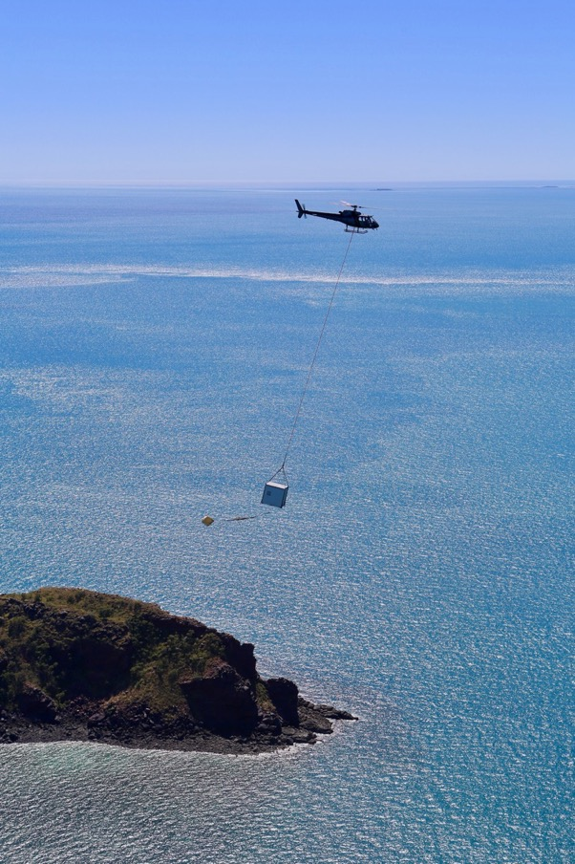

COMPANY PROFILE &   
CAPABILITY STATEMENT

Welcome to KAS Helicopters

The remoteness of the Kimberley region presents significant challenges to business logistics. Vast areas are completely inaccessible by ground vehicles and fixed wing aircraft, representing a significant opportunity for helicopters to provide logistical support for businesses, as well as scenic flights to display the very best of the region to our domestic and international visitors.

Our experience operating in this part of the world is second to none. Our local knowledge, combined with vastly experienced full time local pilots who know the country inside out and are highly skilled in operating in remote and harsh terrain, ensure your aerial support needs are met efficiently and with utmost regard to customer safety.

Our skills encompass far more than just helicopter operations and we can organise total logistics solutions for any job.

*Our primary missions over the last 12 months have included:*

* Surveys
* Heritage Clearance
* Search and rescue
* Aeromedical extractions
* Incendiary burning
* Fire spotting, suppression and support
* Delivery of food and equipment to remote areas
* Sling operations
* Passenger charter operations across the Kimberley
* Superyacht resupply
* Tourism operations and heli-fishing

We have many satisfied clients that we continue to work regularly with, including:

|  |  |
| --- | --- |
| * Australian Wildlife Conservancy * Buru Energy * Broome & Derby Visitor Centres * Cable Beach Club Resort * Dambimangari & Wilinggin Aboriginal Corporations * Department of Fire and Emergency Services * Eco Beach Resort * Kimberley Land Council | * KRSP * Marine Produce Australia * Maxima Pearls * Mount Gibson Iron * Pluton Resources * Royal Flying Doctor Service * Sheffield Resources * Superyachts Australia * Telstra * WA Police |

Approvals and Authorisations

**Authorised Helicopters**

**KAS Helicopters is authorised by CASA to operate the following helicopters in Charter and Aerial Work Operations by day and night:**

* Bell 206
* R44
* R22
* AS350 Squirrel

**Authorised Operations**

**KAS Helicopters is authorised by CASA to conduct the following Aerial Work Operations within Australia.**

1. Aerial Advertising
   1. On aircraft
2. Aerial Photography
   1. Still and motion
   2. Low-level filming
3. Aerial Spotting
   1. Flood
   2. Fauna
   3. Fire
   4. Marine/fish
   5. Flora
4. Aerial Stock Mustering
5. Aerial Surveying
   1. Geo/magno/spectro/seismic
   2. Pipeline inspection
   3. Property survey
   4. Geochemical/sampling
6. Ambulance Functions
7. Dropping
   1. Food and fodder relief
   2. Lifesaving (equipment/personnel)
   3. Messages
   4. Incendiaries (bushfire control)
8. Feral and Diseased Animal Control
9. Powerline
   1. Inspection
10. Search and Rescue
11. Sling Load Operations
12. Surveillance

**CASA Approvals and Exemptions**

**KAS Helicopters has the following additional approvals / exemptions:**

* CAO 48 Flight and Duty Exemptions
* Low Flying Permission
* Operations up to 12nm offshore

Safety

Our safety culture is driven from the top down with Company Directors taking an active role in the Safety Management System, with regular safety meetings, incident and hazard reporting backed up by Air Maestro, a proven aviation software management program.

In addition to standard risk assessments for general flying operations, specific assessments and Safe Work Method Statements are carried out for all new operations and clients, with a view to actively mitigating risk to levels acceptable to KAS and the client.

We are regularly audited by external organisations including SGS Aviation, for our corporate clients such as Telstra. To ensure quality and compliance, we have an internal audit schedule with regular audits of aircraft, emergency equipment, staff recency and flying operations as well as emergency drills and external audits on 3rd party suppliers.

Pilots are subject to 6 monthly flight and proficiency checks, and are required to report all incidents, accidents and hazards immediately verbally to the Chief Pilot and CEO, and in writing via the Air Maestro system.

Safety management group meetings are held minimum quarterly and offer all staff the chance to raise any issues, and review incidents with a view to continuous improvement of our practices and processes.

We ensure compliance with CASA regulations and manufacturers’ recommendations at all times, and in particular require accurate weights for all passenger and cargo to ensure helicopters are not flown overweight.

Pilots

Our full-time pilots are permanent employees who live and play an active role in the regional communities we work in. They are highly experienced in the challenges of flying in the remote and harsh Kimberley environment, and are subject to regular audit, proficiency and flight checks. We also have access to highly skilled pilots available to us on a casual or contract basis at times of high demand.

Importantly, our pilots all possess vital additional skills outside of their flying abilities, from mechanical to construction, logistics, governance, administration and marketing. These skills contribute to our overall operations, enabling most business tasks to be conducted in house without the need for sub-contractors.

Experience

When it comes to delivering equipment and personnel to remote or restricted locations, the helicopter transfer forms a part of an overall logistics solution. Our management team possesses substantial experience in remote area operations and our support can extend far beyond helicopters.

Both Dave and Adrian are no strangers to business in the Kimberley and are highly aware of the unique demands and services that customers require in this remote region of Australia’s Outback. In particular, both partners also possess many years of experience providing professional services to multiple industries, especially oil & gas, mining & exploration.

John French’s local knowledge is a key strength. As Chief Pilot / Head of Flying Operations, he oversees each operation, providing guidance to aircrew to achieve a safe and efficient outcome every flight. With over 30 years flying in the Kimberley, from mustering to medivac, passenger charter and cargo transport, there aren’t many places or tasks Frenchy hasn’t flown!

Facilities / Maintenance

KAS Helicopters’ head office, hangars and maintenance support facilities are located at Derby Airport, Western Australia.

Our facilities allow us to offer our clients air-conditioned briefing rooms / offices, as well as storage space for logistics support.

Derby is ideally located to service a wide area of the West, North and Central Kimberley, with easy access to the Buccaneer Archipelago and north Kimberley coast.

We have a satellite base located at Broome airport to service our tourism clients as well as local charter and corporate clients, and logistics support is also available in Fitzroy Crossing.

Maintenance agreements are in place with Corsaire Aviation Maintenance (turbine) or Heliflite (piston), and all engineering, maintenance, spare parts and inventory control is undertaken by these two well regarded organisations.

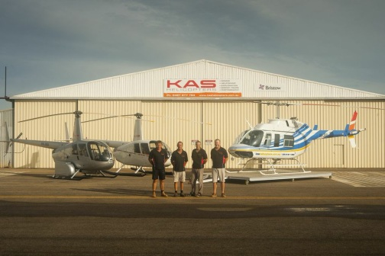

Communications / Tracking

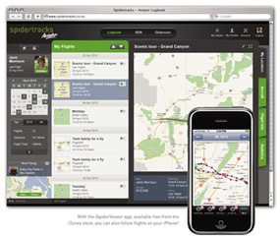All KAS helicopters are fitted with satellite technology to track in flight operations.

Helicopters are equipped with either Spidertrqcks (turbine aircraft) or Spot Trackers (piston aircraft) fitted to each machine. Using GPS accuracy, it is possible to obtain highly accurate fixes and view them on a global map. Clients are able to log into these systems to track live progress.

Aircrew can also send routine and emergency messages via satellite. These messages are automatically dispatched to operations staff via e-mail and mobile phone text message.

All aircraft are fitted with fixed or handheld ELTs, dual VHF radios

and UHF radios. CKT also has a WAERN radio for communicating on the emergency services network. Portable satellite phones complete the communications package.

Additional Business Support

In addition to our helicopter operations, we can directly offer or recommend:

* Vehicle Hire (passenger and commercial)
* Fixed Wing Charter
* Equipment Hire
* Accommodation
* Transport and Logistics Solutions

Ground Support

Our large range of support vehicles and equipment combined with local and logistics experience, enables us to provide ground support and logistics solutions to support remote operations.

* Landcruiser tray back 4WD with self-loading crane for transport of fuel and equipment
* Landcruiser Prado 4WD for transport of KAS crew and GA crew (7 seats)
* Tandem axle off road capability for transport of fuel and equipment
* Tandem axle off road capability 2000 litre Jet A1 fuel trailer
* 8T capacity tray top  truck
* Drumstock fuel pre-positioned at remote locations prior to wet season



Indigenous Engagement

We acknowledge and respect the Traditional Owners of the Kimberley.

We engage through our established commercial client relationships with Kimberley Land Council, Dambimangari and Wilinggin Aboriginal Corporations and through regular contact with the Elders of communities throughout the Kimberley Region.

We provide no-cost initial and safety training for the many Aboriginal people who fly as passengers, operate incendiary machines and undertake surveys from our aircraft, as well as seeking ongoing mentoring and opportunities.

We are also extremely sensitive to land access and ensure that the necessary approvals and permissions are obtained for landing on remote sites, respecting the cultural sensitivity of such places

In addition, we use local Aboriginal subcontractors wherever possible, such as for electrical work in our facilities.

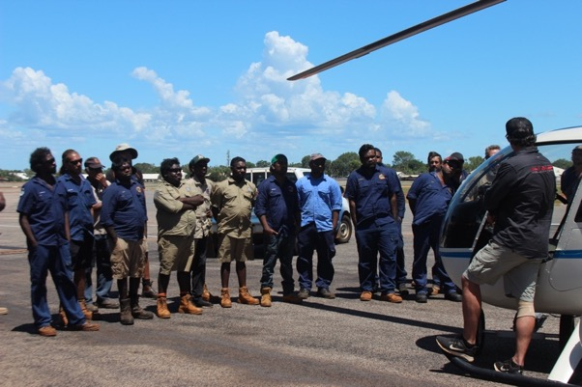

The Fleet

KAS Helicopters’ current fleet consists of:

* 1 Eurocopter AS350 B2 Squirrel
* 1 B206L Long Ranger
* 3 Robinson 44s (3 Raven I and 1 Clipper/Raven II)

The depth and breadth of this fleet enables us to offer clients the most suitable aircraft for each task, and allow for planned and unscheduled maintenance with minimum disruption to operations.

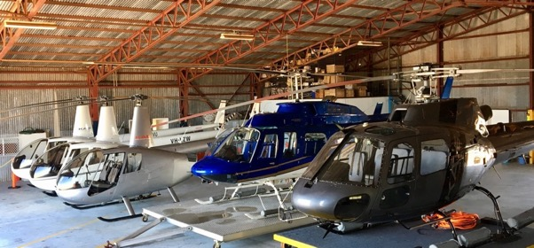

Aircraft Details

**Helicopter Details – B206L Long Ranger (1 in fleet) VH-CKT**

**Model:** Bell 206L - Long Ranger

**Operations permitted:** Charter / Aerial Work, Day / Night VFR

**Engine:** Rolls Royce 250-C30P Turbine

**Long Ranger Specifications**

* **Cruising airspeed:** 190km/h
* **Safe range with full fuel:** 495km
* **Payload with full fuel:** 309kg
* **Maximum return to base range with 30 minutes on station:** 193km
* **Maximum payload – 300km Return (90 mins flight):** 462kg out, 550kg back
* **Maximum passenger seating:**  6

**Long Ranger Features**

* External cargo hook
* Intercom front and rear
* Pop out emergency floats for over water transport
* Quick Fit Stretcher for Patient Transfer and SAR Missions
* WAERN radio, fixed ELT, 2 VHF radios, UHF radio, satellite phone
* Spidertracks Satellite Tracking System
* Engineering order for Raindance incendiary machine installation



**Helicopter Details – AS350 B2 Squirrel (1 in fleet) VH-JYN**

**Model:** Eurocopter AS350 B2 Squirrel ‘

**Operations permitted:** Charter / Aerial Work, Day / Night VFR

**Engine:** Ariel 1D1 Turbine

**Squirrel Specifications**

* **Cruising airspeed:** 195km/h
* **Safe range with full fuel:** 525km
* **Payload with full fuel:** 480kg
* **Maximum return to base range with 30 minutes on station:** 215km
* **Maximum payload – 300km Return (90 mins flight):** 550kg out, 650kg back
* **Maximum passenger seating:**  5

**Squirrel Features**

* Air conditioned for maximum passenger comfort / fatigue management
* External cargo hook
* Intercom front and rear
* Pop out emergency floats
* Wire strike protection
* Dart utility basket
* Fixed ELT, dual VHF radio, UHF radio, satellite phone
* Spidertracks satellite tracking system
* Engineering order for Raindance incendiary machine installation

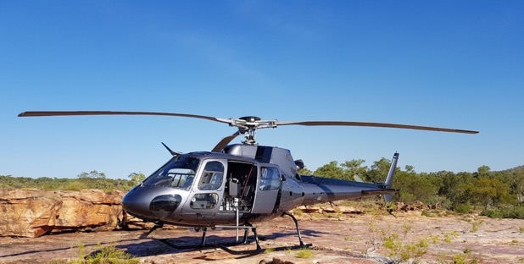

*AS350 B2 Squirrel in the field with Raindance   
incendiary burning machine installed*

**Helicopter Details – Robinson 44 (3 in fleet) VH-ADC, ZVU, ZWU**

**Models:** Raven I / Clipper II

**Operations permitted:** Charter / Aerial Work

**Engine:** Lycoming 6 cylinder, horizontally opposed piston.

**R44 Specifications**

* **Cruising airspeed:** 190km/h
* **Safe range with full fuel:** 430km
* **Payload with full fuel:** 220 kg
* **Maximum return to base range with 30 minutes on station:** 165 km
* **Maximum payload - 300km return (90 mins flight):** 260 kg
* **Maximum passenger seating:**  3

**R44 Features**

* External cargo hook
* Emergency pop-out floats for overwater operations (ZVU)
* Heli-Pods / Litter Racks for external baggage / tool / cargo transport
* Air-conditioning (ZVU)
* SpotGen3 Satellite Tracking System
* Engineering order for Raindance incendiary machine installation
* Dual VHF radios, UHF radio, fixed or hand held ELTs, satellite phone



Staff

**Adrian Crook – CEO / Pilot**

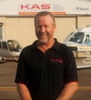

Adrian founded a successful transport and logistics company which serviced the Kimberley from Perth for nearly two decades. The company was sold to an ASX-listed company in Jan 2010 and continues to go from strength to strength.

Adrian is a graduate of the Curtin Business School and is a Chartered Member of the Institute of Logistics & Transport. In addition to his role as CEO of KAS, he continues to be actively involved in the transport and logistics industry through his consulting business.

**Hours**

550

**Types**

R22

R44

B206/L

**Endorsements**

Sling

Low level

**David Preedy – Director Finance / Pilot**

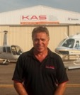

**Hours**

650

**Types**

R22

R44

Dave has proudly been a Derby local for 30 years.

He has a strong track record in local business ventures, and currently owns Kimberley Car Hire in addition to his role as Director – Finance at KAS.

He has a passion for heli-fishing and knows all the best local spots to visit.

**John French – Chief Pilot / Head of Flying Operations**



**Hours**

10000

**Types**

R22

R44

B206/L

AS350

**Endorsements**

Night VFR

Sling

Mustering

Low level

John is very well known and respected throughout the Kimberley and Pilbara. He started out mustering and has since clocked up many hours conducting feral animal control, mining and geological surveys, with a vast knowledge of the local region.

His incident free flying career over nearly 30 years highlights his professional, proactive and safety conscious attitude.

As Chief Pilot, John is responsible for the company’s regular checks and training of all KAS pilots.

**Roger Nowland – Senior Line Pilot / Type Specialist - Derby**

Roger has an aviation career that spans over 35 years and 15,000 total hours across fixed wing and rotary aircraft. He is a skilled, immensely experienced commercial pilot, particularly when it comes to working in remote areas.

The call of the Kimberley lured Roger back a few years ago, having previously worked here for years in the mustering industry in the 1990s. This means he knows the country inside out and is very familiar flying in harsh terrain.

Roger brings a wealth of knowledge to the company with his extensive experience in multiple helicopter types and many and varied work experiences.

**Hours**

13000

**Types**

R22

R44

B47

H500

B206/L

AS350

**Endorsements**

Night VFR

Sling

Mustering

Low Level

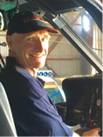

**Mick McGee – Line Pilot – Derby**

Mick has recently returned to the Kimberley to join our Derby team as a full-time line pilot.

He first learnt to fly in New Zealand and after a few years on the ground in the agriculture industry gained his commercial helicopter licence, working in aerial Ag operations before he decided to cross the Tasman and fly on stations in the Kimberley.

Mick has experience flying different machines in a wide variety of operations and conditions both in Australia and NZ.

**Hours**

1200

**Types**

R22

R44

B206/L

**Endorsements**

Sling

Low Level

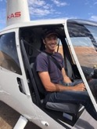

**Hilary Wilkins – Broome Base Manager / Pilot**

Hilary has lived in Broome for 10 years and is a passionate advocate for the Kimberley.

She brings a wealth of knowledge and skills from a corporate and government career spanning 20 years in the UK and Australia, including stakeholder management, governance, administration, marketing, contract administration and project management.

Hilary oversees our Broome operations in her role as Base Manager and plays a vital role assisting the management team to ensure KAS’ systems and operations are compliant with the necessary legislation and regulations.

**Hours**

820

**Types**

R22

R44

**Endorsements**

Low level

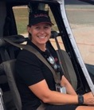

Contact Information

Operations: 1300 405545

[admin@kashelicopters.com](mailto:admin@kashelicopters.com)

[www.kashelicopters.com.au](http://www.kashelicopters.com.au)

Broome: Charter Aircraft Base, Gus Winckel Drive, Broome Airport.

Derby: Hangar 5, Airport Drive, Derby Airport.

|  |  |  |
| --- | --- | --- |
| John French | Adrian Crook | Dave Preedy |
| 0417 172 971 | 0419 933 900 | 0408 931 919 |

